**Customized Solution for Solar**

**Within 5 mins.**

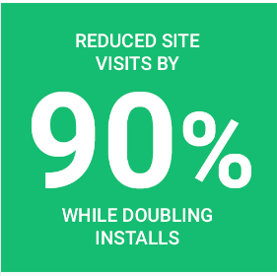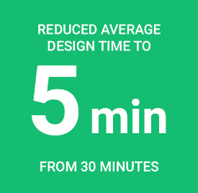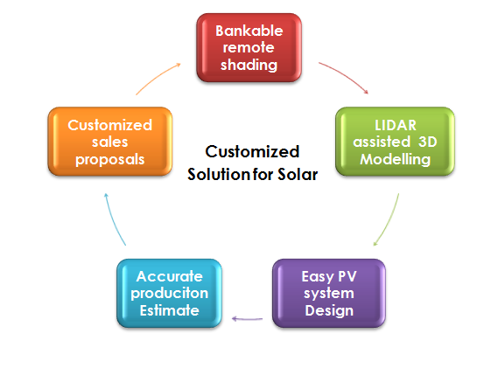

Should remove exclamation points.

Financing for Investors and Financing for Customers should be entirely separate.

Link to investors should maybe be at the bottom. The main page is for customers.

|  |  |
| --- | --- |
| **On website now:** | **Suggested change:** |
| Request for a Demo! | Request a Demo |
| what we do? | End-to-End Solutions |
| Markets | Which Business Can Benefit? |
| Pharma | *Remove Pharma pic or add pics of two more types of businesses, so the grid is even. 6 or 9.* |
| Tailormade Solutions | Customized Solutions |
| BOM | *Remove? Why is this here?* |
| Instant Layout | Optimized Solar Panel Layout |
| No Upfront Cost! | No Upfront Costs |
| Seeking Early Project Discovery and Higher ROI… Learn more! | Seeking Higher ROI? Learn More |
|  |  |

|  |  |  |  |
| --- | --- | --- | --- |
| NexGen projects support the UN Sustainable Development Goals (SDGs) | | | |
| C:\Users\user\Desktop\website\7.png | C:\Users\user\Desktop\website\8.png | C:\Users\user\Desktop\website\11.png | C:\Users\user\Desktop\website\13.png |

# Ethical investments that fight climate change: How it works

**PPA agreement**

LEND MONEY

Principal plus interest

PAY AS PER TARIFF

**NGS**

**Benefits for Investors**

## 3 Easy Steps to Investing

Investor FAQ

Invest Now

IF YOU CLICK ON INVEST NOW ONE POPUP BOX SHOULD OPEN

|  |
| --- |
| INVEST WITH US, Give us your contact information and we’ll get back to you  NexGen Solar Logo  SUBMIT  ARE YOU AN ACCREDITED INVESTPOR (Your personal net asset(s) is in excess of $2 million. – YESO NO O  LOCATION  TYPE OF INVESTOR  LAST NAME  PHONE  EMAIL  FIRST NAME |

**Benefits for Energy Customers**

## 3 Easy Steps to Project Funding

# Sustainable and ethical investments that empower you to fight climate change

## Benefits of a Managed Portfolio

Managed Portfolio is the easiest way to fill a gap in your portfolio with private renewable energy investments.

|  |  |  |
| --- | --- | --- |
| C:\Users\user\Desktop\website\GLOBE.jpg | C:\Users\user\Desktop\website\RISK.jpg | C:\Users\user\Desktop\website\cashflow.jpg |
| Portfolio Diversification | Lowering Risk | Cash flow |
| Benefit from investment opportunities across different states and asset types in the one of the top emerging country | Invest in multiple assets at a substantially lower minimum compared to investing in individual assets. | Renewable energy investments are annuity style investments. The cash flow is locked in typically over 7 to 20 years. |

## What makes Renewable Energy Assets unique?

We help you diversify your asset allocation with private renewable energy assets to create a more efficient portfolio and improve your risk-adjusted returns.

|  |  |  |  |
| --- | --- | --- | --- |
| **Low Return** | **Less Volatile** | | **High Return** |
| C:\Users\user\Desktop\website\bond.jpg | C:\Users\user\Desktop\website\clean-energy-investment.jpg |
| C:\Users\user\Desktop\website\reit.jpg | C:\Users\user\Desktop\website\equity-1200.jpg |
| **More Volatile** | |

## The Benefits of Investing with NexGen Solar

## 15%+

**Net IRR for medium to large scale solar rooftop or Ground mount projects**

## 5 - 20 years

**Tenure of Investment**

## 5 - 6 years

**Break Even Period**

## 2.1 - 3.5 X +

**Target total return**

## Impact Investing

### Investing with NexGen Solar is an opportunity to have a meaningful impact in the real world.

|  |  |  |
| --- | --- | --- |
| C:\Users\user\Desktop\website\envo frind.png | C:\Users\user\Desktop\website\SDG.png | C:\Users\user\Desktop\website\EMERGING.jpg |
| Environment Friendly | Aligned with UN SDGs | Developing Economy (GDP growth is approx 7-8%) |
| We focus on investments in solar rooftop, which enables traditional industries to change their power source to clean energy. | We meet the criteria for multiple UN Sustainable Development Goals by helping investors invest in public goods. | We focus on investments in India where access to capital for renewable energy is low. |